**LAB TASK_9**

SUBMITTED BY: SHARIFULLAH

SUBMITTED TO: MR. BASIT ALI

1. Add a single row in regions table

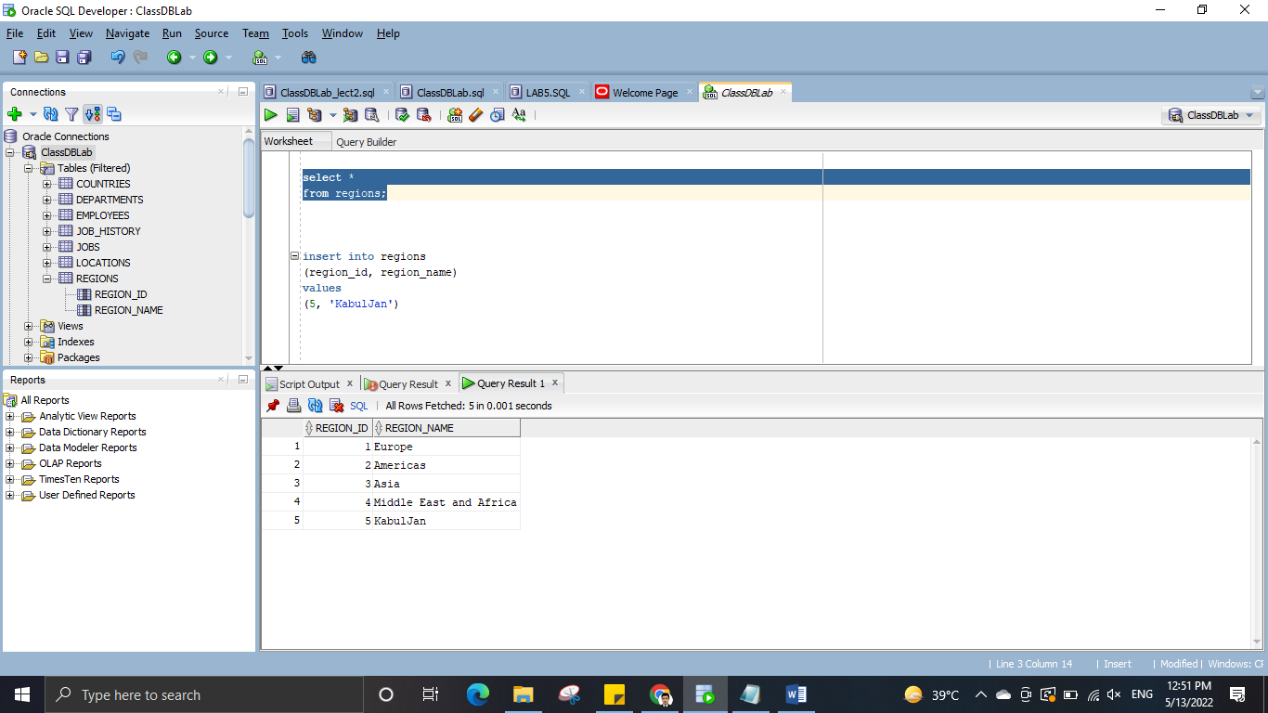

1. Add a single row in the countries table using region_id which you have created previously in q1.

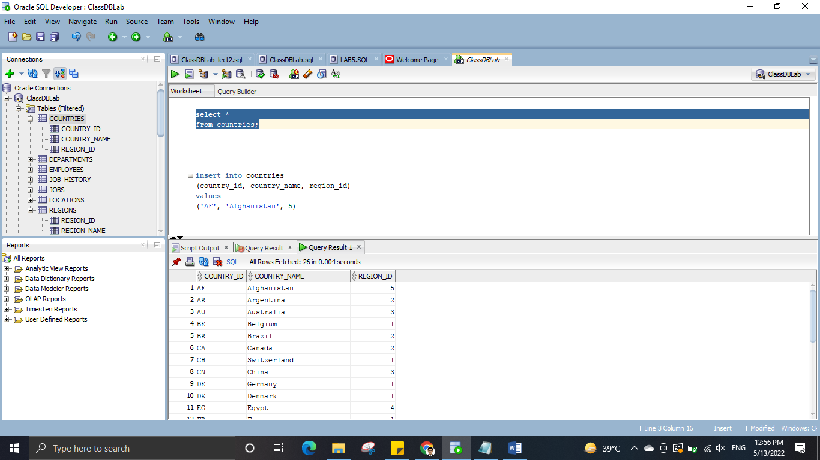

1. Add a single row in location table. (use country id which you created previously in q2)

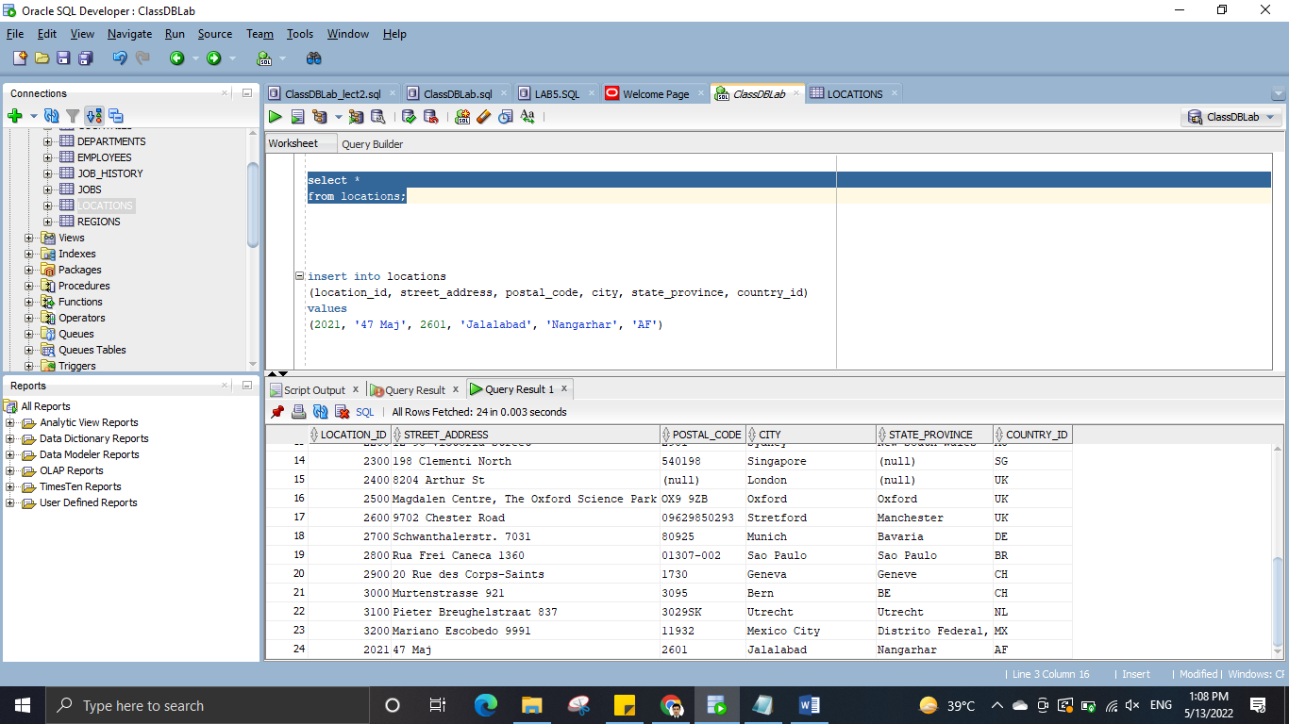

1. Add a single row in departments table. (use location id which you have created previously in q3.)

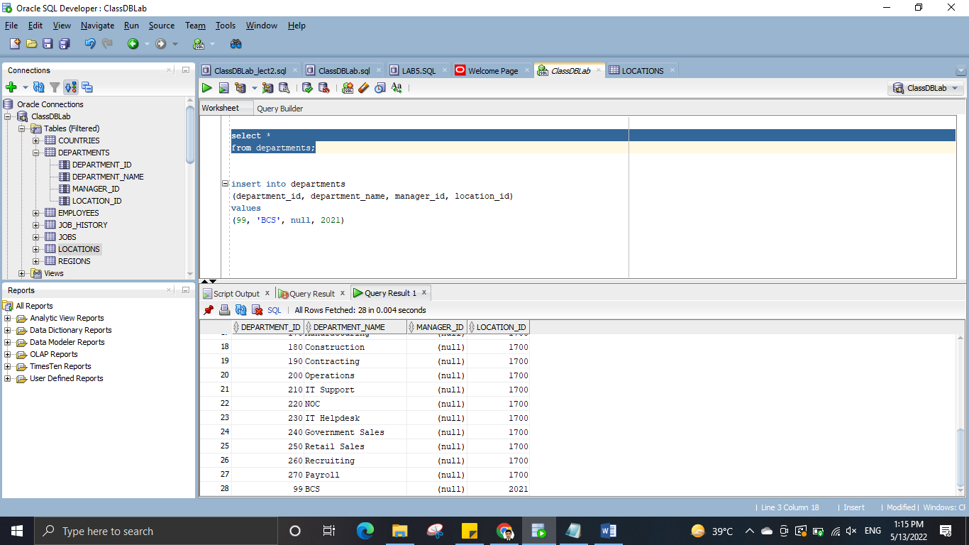

1. Add a single row in jobs table. (the title of the job should software engineer.)

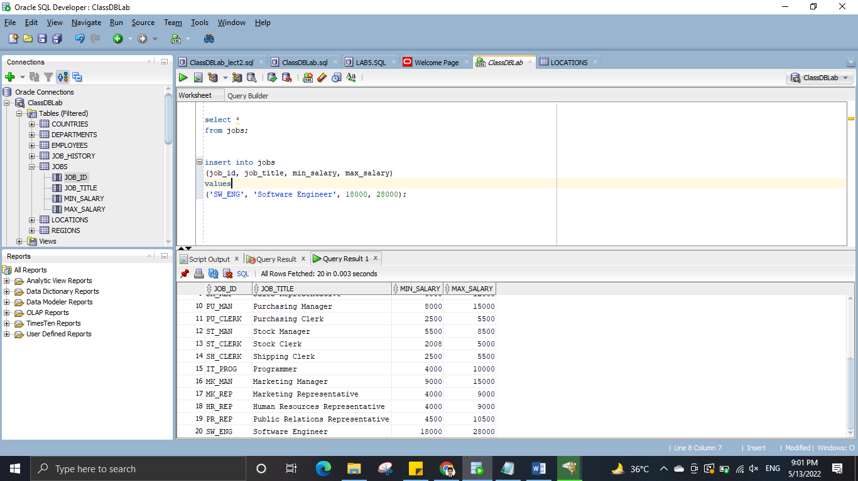

1. Add a single row in employees table – use the above department and job _id. (Use department

id and job_id which you created previously in q1. Employee name details should be your own.

You can use dummy data as your contact details (i-e email and number))

